1. Grouped Bar Chart – Monthly Product Sales
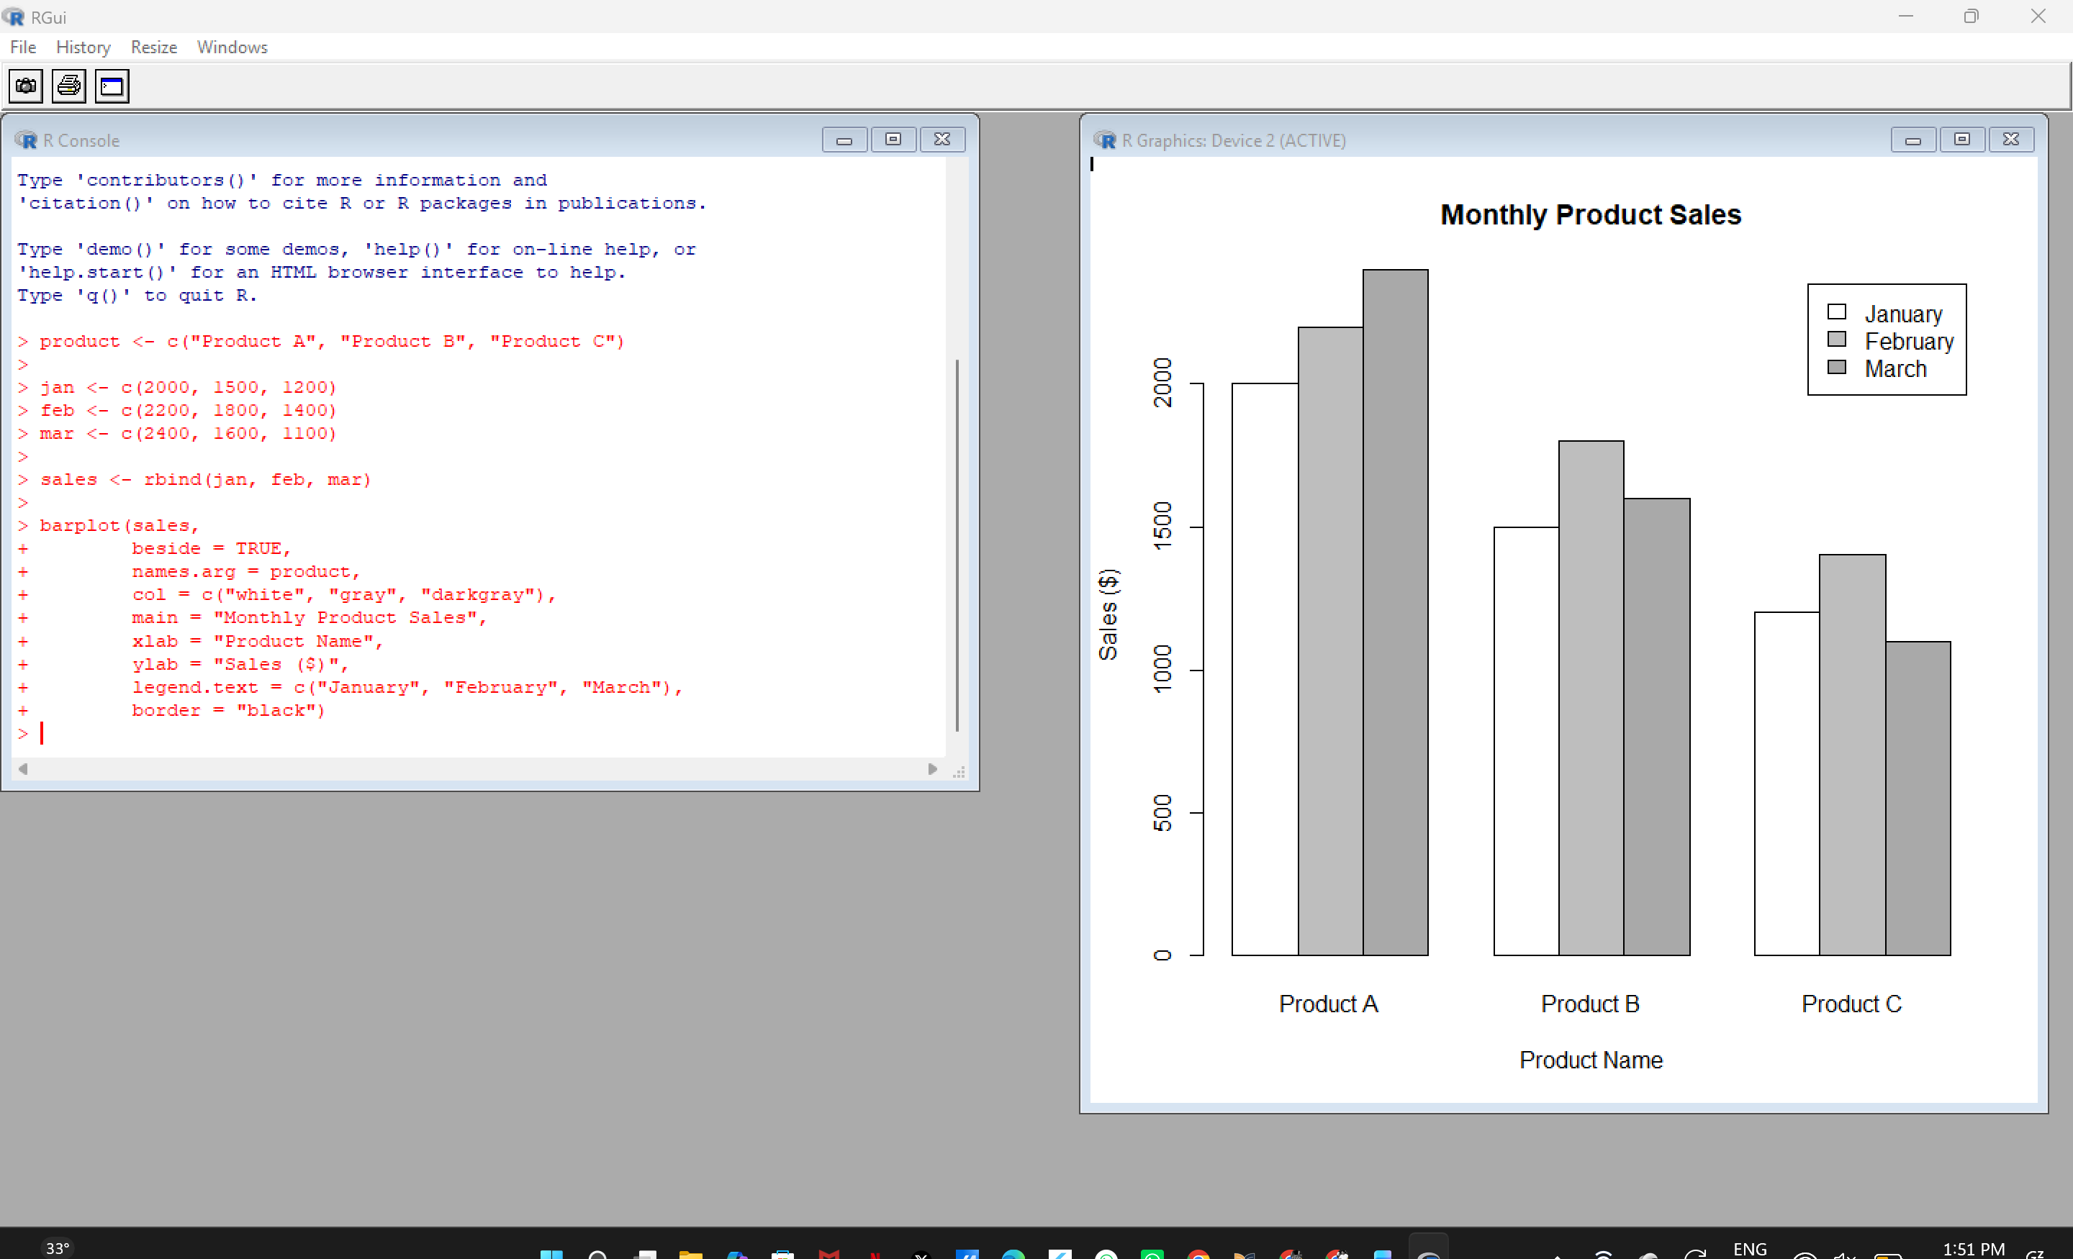

2. Stacked Area Chart – Overall Sales Trend
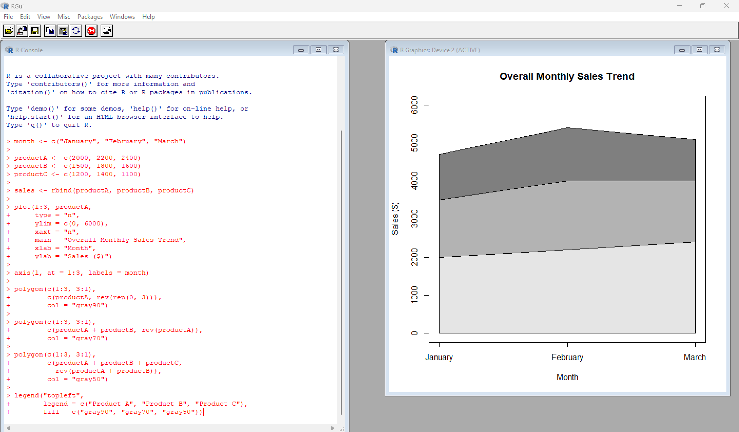
3. Table – Monthly Sales Data
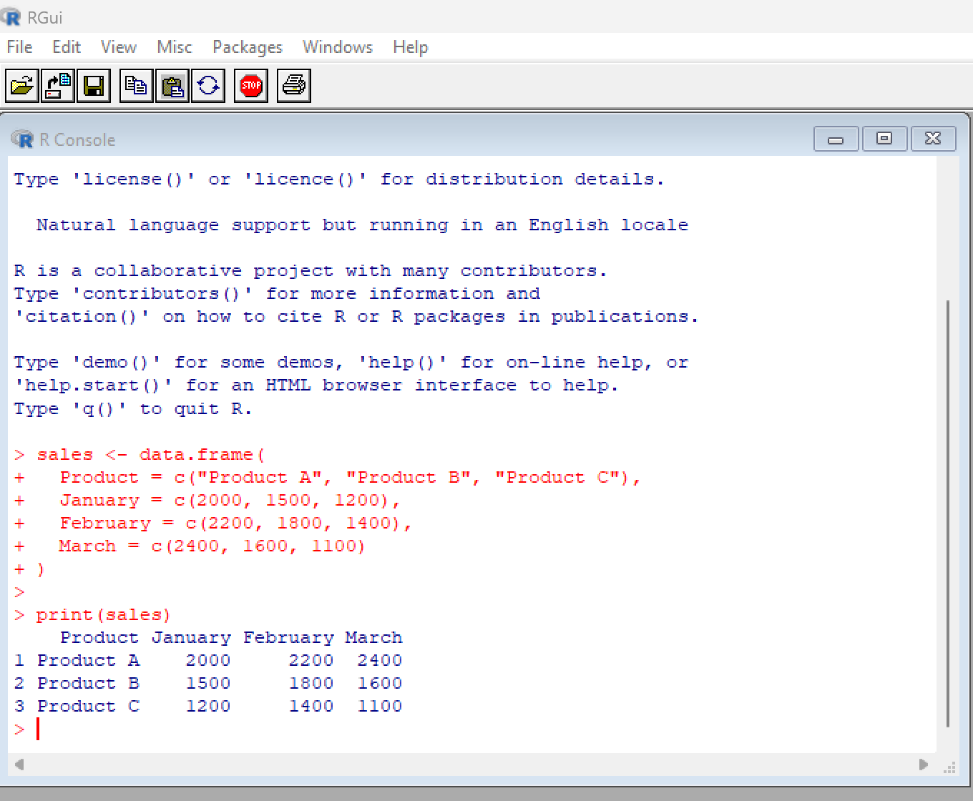
4. Tableau Dashboard
